SEXUAL INDOCTRINATION
IN PUBLIC SCHOOLS
WHAT PARENTS NEED TO KNOW AND WHAT THEY CAN DO

Caryl Ayala

concernedparentsoftexas.com info@concernedparentsoftexas.com

Hello,
My name is Caryl Ayala and I am one of the co-founders of Concerned Parents of Texas.
When I left my teaching career of 20 years, after being trained in the Welcoming Schools Program at my elementary school campus, I was not sure how deeply people would be concerned about their children being indoctrinated in LGBTQ issues beginning in pre-kindergarten. I only knew that, whatever else I did, parents had a right to know what their impressionable minor children were being taught in classrooms without their knowledge concerning Lesbian, Gay, Bisexual and Transgender information in Austin and across Texas.
It is my belief that parenting is a God- given gift and that parents—not educators—are ultimately responsible for what their children are taught, no matter how well-intentioned the educators may be.
It is my prayer that parents will reclaim their responsibility as a child’s first and primary educator and become engaged in all levels of their education, both academically and spiritually.

Blessings,
Caryl Ayala

www.concernedparentsoftexas.com

We have put these resources together and hope they will be helpful in any way you choose to use them.

Table of Contents

- You’re Teaching My Child What? By Dr. Miriam Grossman M.D.
- Texas Education Code – EDUC 28.004
Local School Health Advisory Council and Health Education Instruction
- What is a SHAC?
- Types of Sex Education – SRA and SRR Comparison Chart
- Promiscuity, Not Prevention
- Harming Their Innocence – An Example of a Current Curriculum
- When in Doubt, Opt Out
- Parent Action Guide
- Texas State Parent and Student Opt-Out Notice
- Texas School Board Policy – Uphold Texas Age of Consent and Biological Reality
- Texas School Board Policy – Texas Age of Consent Law
- Texas School Board Policy – Objective Biological Reality
- Texas School Board Policy – Student Physical Privacy Policy
- The Best for Children – Fact Sheet
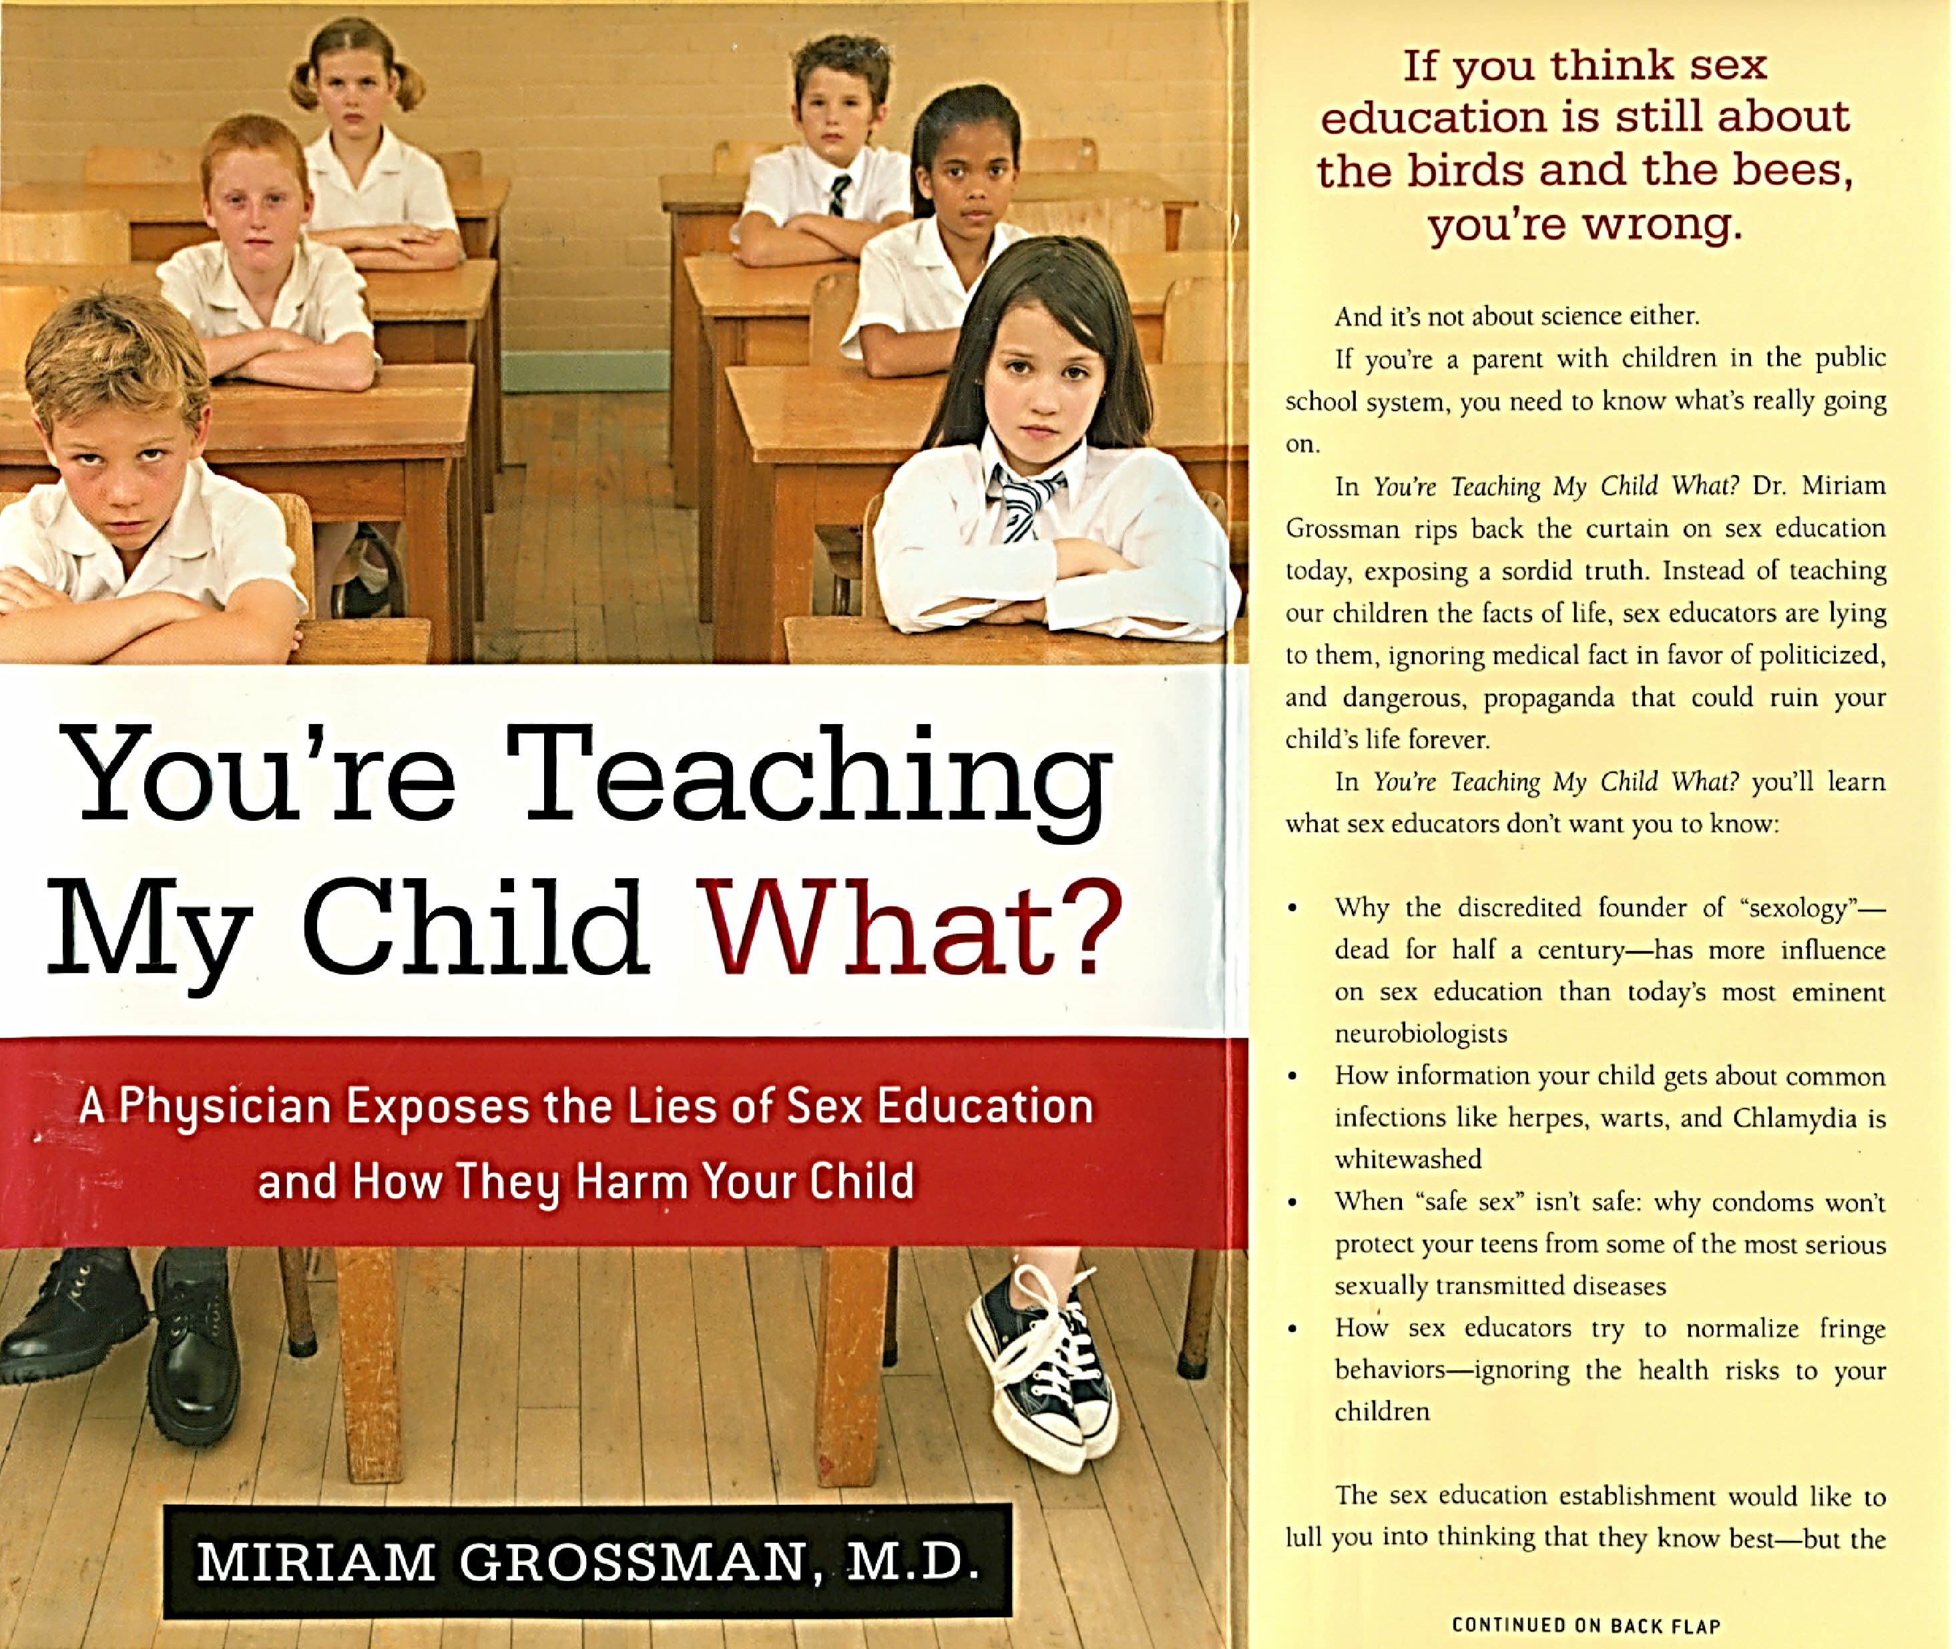
Texas Education Code - EDUC § 28.004.
Local School Health Advisory Council and Health Education Instruction
Sec. 28.004. LOCAL SCHOOL HEALTH ADVISORY COUNCIL AND HEALTH EDUCATION INSTRUCTION. (a) The board of trustees of each school district shall establish a local school health advisory council to assist the district in ensuring that local community values are reflected in the district's health education instruction.
(b) A school district must consider the recommendations of the local school health advisory council before changing the district's health education curriculum or instruction.
(c) The local school health advisory council's duties include recommending:
(1) the number of hours of instruction to be provided in:
(A) health education in kindergarten through grade eight; and
(B) if the school district requires health education for high school graduation, health education, including physical health education and mental health education, in grades 9 through 12;
(2) policies, procedures, strategies, and curriculum appropriate for specific grade levels designed to prevent physical health concerns, including obesity, cardiovascular disease, Type 2 diabetes, and mental health concerns, including suicide, through coordination of:
(A) health education, which must address physical health concerns and mental health concerns to ensure the integration of physical health education and mental health education;
(B) physical education and physical activity;
(C) nutrition services;
(D) parental involvement;
(E) instruction on substance abuse prevention;
(F) school health services, including mental health services;
(G) a comprehensive school counseling program under Section 33.005;
(H) a safe and healthy school environment; and
(I) school employee wellness;
(3) appropriate grade levels and methods of instruction for human sexuality instruction;
(4) strategies for integrating the curriculum components specified by Subdivision (2) with the following elements in a coordinated school health program for the district:
(A) school health services, including physical health services and mental health services, if provided at a campus by the district or by a third party under a contract with the district;
(B) a comprehensive school counseling program under Section 33.005;
(C) a safe and healthy school environment; and
(D) school employee wellness;
(5) if feasible, joint use agreements or strategies for collaboration between the school district and community organizations or agencies;
(6) strategies to increase parental awareness regarding:
(A) risky behaviors and early warning signs of suicide risks and behavioral health concerns, including mental health disorders and substance use disorders; and
(B) available community programs and services that address risky behaviors, suicide risks, and behavioral health concerns;
(7) appropriate grade levels and curriculum for instruction regarding opioid addiction and abuse and methods of administering an opioid antagonist, as defined by Section 483.101, Health and Safety Code; and
(8) appropriate grade levels and curriculum for instruction regarding child abuse, family violence, dating violence, and sex trafficking, including likely warning signs that a child may be at risk for sex trafficking, provided that the local school health advisory council's recommendations under this subdivision do not conflict with the essential knowledge and skills developed by the State Board of Education under this subchapter.
(d) The shall board of trustees appoint at least five members to the local school health advisory council. A majority of the members must be persons who are parents of students enrolled in the district and who are not employed by the district. One of those members shall serve as chair or co-chair of the council. The board of trustees also may appoint one or more persons from each of the following groups or a representative from a group other than a group specified under this subsection:
(1) classroom teachers employed by the district;
(2) school counselors certified under Subchapter B, Chapter 21, employed by the district;
(3) school administrators employed by the district;
(4) district students;
(5) health care professionals licensed or certified to practice in this state, including medical or mental health professionals;
(6) the business community;
(7) law enforcement;
(8) senior citizens;
(9) the clergy;
(10) nonprofit health organizations; and
(11) local domestic violence programs.
(d-1) The local school health advisory council shall meet at least four times each year. For each meeting, the council shall:
(1) at least 72 hours before the meeting:
(A) post notice of the date, hour, place, and subject of the meeting on a bulletin board in the central administrative office of each campus in the school district; and
(B) ensure that the notice required under Paragraph (A) is posted on the district's Internet website, if the district has an Internet website;
(2) prepare and maintain minutes of the meeting that state the subject and content of each deliberation and each vote, order, decision, or other action taken by the council during the meeting;
(3) make an audio or video recording of the meeting; and
(4) not later than the 10th day after the meeting, submit the minutes and audio or video recording of the meeting to the district.
(d-2) As soon as practicable after receipt of the minutes and audio or video recording under Subsection (d-1)(4), the school district shall post the minutes and audio or video recording on the district's Internet website, if the district has an Internet website.
(e) Any course materials and instruction relating to human sexuality, sexually transmitted diseases, or human immunodeficiency virus or acquired immune deficiency syndrome shall be selected by the board of trustees with the advice of the local school health advisory council and must:
(1) present abstinence from sexual activity as the preferred choice of behavior in relationship to all sexual activity for unmarried persons of school age;
(2) devote more attention to abstinence from sexual activity than to any other behavior;
(3) emphasize that abstinence from sexual activity, if used consistently and correctly, is the only method that is 100 percent effective in preventing pregnancy, sexually transmitted diseases, infection with human immunodeficiency virus or acquired immune deficiency syndrome, and the emotional trauma associated with adolescent sexual activity;
(4) direct adolescents to a standard of behavior in which abstinence from sexual activity before marriage is the most effective way to prevent pregnancy, sexually transmitted diseases, and infection with human immunodeficiency virus or acquired immune deficiency syndrome; and
(5) teach contraception and condom use in terms of human use reality rates instead of theoretical laboratory rates, if instruction on contraception and condoms is included in curriculum content.
(e-1) The board of trustees shall adopt a policy establishing a process for the adoption of curriculum materials for the school district's human sexuality instruction. The policy must require:
(1) the board to adopt a resolution convening the local school health advisory council for the purpose of making recommendations regarding the curriculum materials;
(2) the local school health advisory council to:
(A) after the board's adoption of the resolution under Subdivision (1), hold at least two public meetings on the curriculum materials before adopting recommendations; and
(B) provide the recommendations adopted under Paragraph (A) to the board at a public meeting of the board; and
(3) the board, after receipt of the local school health advisory council's recommendations under Subdivision (2), to take action on the adoption of the recommendations by a record vote at a public meeting.
(e-2) curriculum materials proposed to be adopted for the school district's human sexuality instruction must be made available as provided by Subsection (j)(1) or (2)(A) or (C), as applicable.
(e-3) Before adopting curriculum materials for the school district's human sexuality instruction, the board of trustees shall ensure that the curriculum materials are:
(1) based on the advice of the local school health advisory council;
(2) suitable for the subject and grade level for which the curriculum materials are intended; and
(3) reviewed by academic experts in the subject and grade level for which the curriculum materials are intended.
(f) A school district may not distribute condoms in connection with instruction relating to human sexuality.
(g) A school district that provides human sexuality instruction may separate students according to sex for instructional purposes.
(h) The board of trustees shall determine the specific content of the district's instruction in human sexuality, in accordance with this section.
(i) Before each school year, a school district shall provide written notice to a parent of each student enrolled in the district of the board of trustees' decision regarding whether the district will provide human sexuality instruction to district students. If instruction will be provided, the notice must include:
(1) a statement informing the parent of the human sexuality instruction requirements under state law;
(2) a detailed description of the content of the district's human sexuality instruction and a general schedule on which the instruction will be provided;
(3) a statement of the parent's right to:
(A) at the parent's discretion, review or purchase a copy of curriculum materials as provided by Subsection (j);
(B) remove the student from any part of the district's human sexuality instruction without subjecting the student to any disciplinary action, academic penalty, or other sanction imposed by the district or the student's school; and
(C) use the grievance procedure as provided by Subsection (i-1) or the appeals process under Section 7.057 concerning a complaint of a violation of this section;
(4) a statement that any curriculum materials in the public domain used for the district's human sexuality instruction must be posted on the district's Internet website, if the district has an Internet website, and the Internet website address at which the curriculum materials are located; and
(5) information describing the opportunities for parental involvement in the development of the curriculum to be used in human sexuality instruction, including information regarding the local school health advisory council established under Subsection (a).
(i-1) A parent may use the grievance procedure adopted under Section 26.011 concerning a complaint of a violation of this section.
(i-2) Before a student may be provided with human sexuality instruction, a school district must obtain the written consent of the student's parent. A request for written consent under this subsection:
(1) may not be included with any other notification or request for written consent provided to the parent, other than the notice provided under Subsection (i); and
(2) must be provided to the parent not later than the 14th day before the date on which the human sexuality instruction begins.
(i-3) Subsection (i-2) and this subsection expire August 1, 2024.
(j) A school district shall make all curriculum materials used in the district's human sexuality instruction or instruction relating to the prevention of child abuse, family violence, dating violence, and sex trafficking, available by:
(1) for curriculum materials in the public domain:
(A) providing a copy of the curriculum materials by mail or e-mail to a parent of a student enrolled in the district on the parent's request; and
(B) posting the curriculum materials on the district's Internet website, if the district has an Internet website; and
(2) for copyrighted curriculum materials, allowing a parent of a student enrolled in the district to:
(A) review the curriculum materials at the student's campus at any time during regular business hours;
(B) purchase a copy of the curriculum materials from the publisher as provided by the district's purchase agreement for the curriculum materials under Subsection (j-1) or (j-2); or
(C) review the curriculum materials online through a secure electronic account in a manner that prevents the curriculum materials from being copied and that otherwise complies with copyright law.
(j-1) If a school district purchases from a publisher copyrighted curriculum materials for use in the district's human sexuality instruction, the district shall ensure that the purchase agreement provides for a means by which a parent of a student enrolled in the district may purchase a copy of the curriculum materials from the publisher at a price that does not exceed the price per unit paid by the district for the curriculum materials.
(j-2) If a school district purchases from a publisher copyrighted curriculum materials for use in the district's instruction relating to the prevention of child abuse, family violence, dating violence, and sex trafficking, the district shall ensure that the purchase agreement provides for a means by which a parent of a student enrolled in the district may purchase a copy of the curriculum materials from the publisher at a price that does not exceed the price per unit paid by the district for the curriculum materials.
(k) A school district shall publish in the student handbook and post on the district's Internet website, if the district has an Internet website:

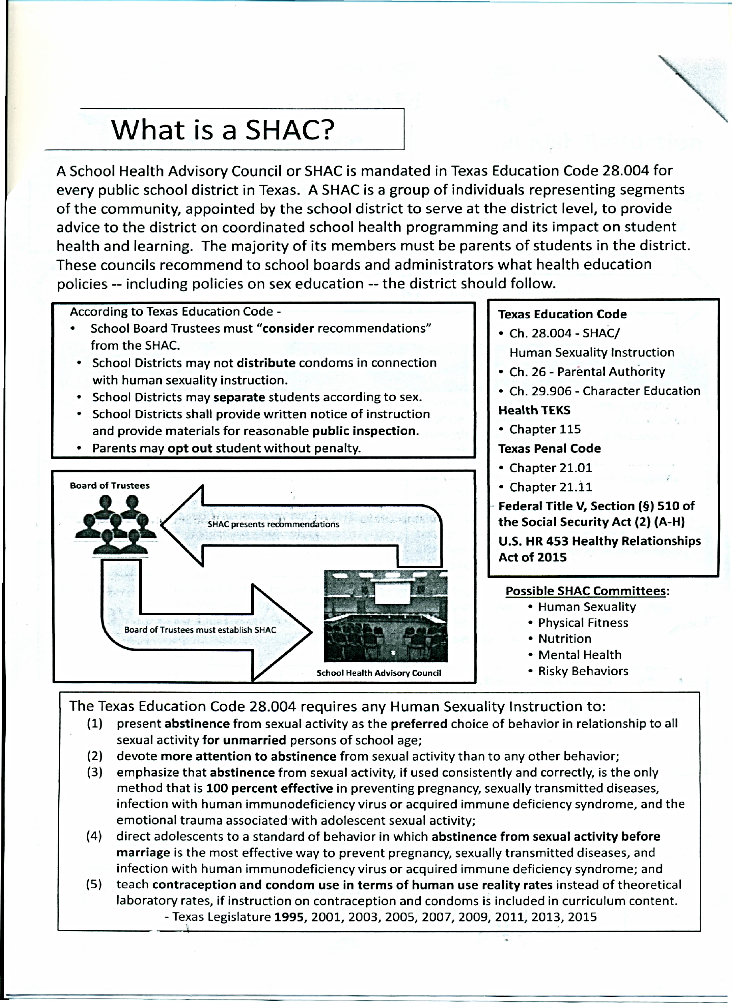
SRA  Sexual Risk Avoidance | SRR  Sexual Risk Reduction
- Living Well Aware (Formerly Worth the Wait)  http://www.livingwellaware.com  - Choosing the Best  http://www.choosingthebest.com/  - Heritage Keepers  http://www.heritageservices.org/  - Aim for Success/Just Say Yes  http://www.aimforsuccess.org  - Austin Lifeguard  http://www.lifeguard-tx.org | - Big Decisions  http://www.bigdecisions.org/  - Draw the Line/Respect the Line  https://www.etr.org/ebi/programs/draw-the-line/  - It’s Your Game  https://sph.uth.edu/tprc/its-your-game/  - Reducing the Risk  https://www.etr.org/ebi/programs/reducing-the-risk/

Sources for information about SRA programs:
- Ascend
https://weascend.org/
- The Policy Paper Series: A Better Approach to Teenage Pregnancy Prevention: Sexual Risk Avoidance. (Jemmott Study)
https://archives-energyommerce.house.gov/sites/republicans.energycommerce.house.gov/files/analysis/20120706riskavoidance.pdf
- New York City Sexuality Education Report. Grossman, Miriam, M.D. 2011.
http://www.miriamgrossmanmd.com/wp-content/uploads/2012/11/sex_ed_report.pdf

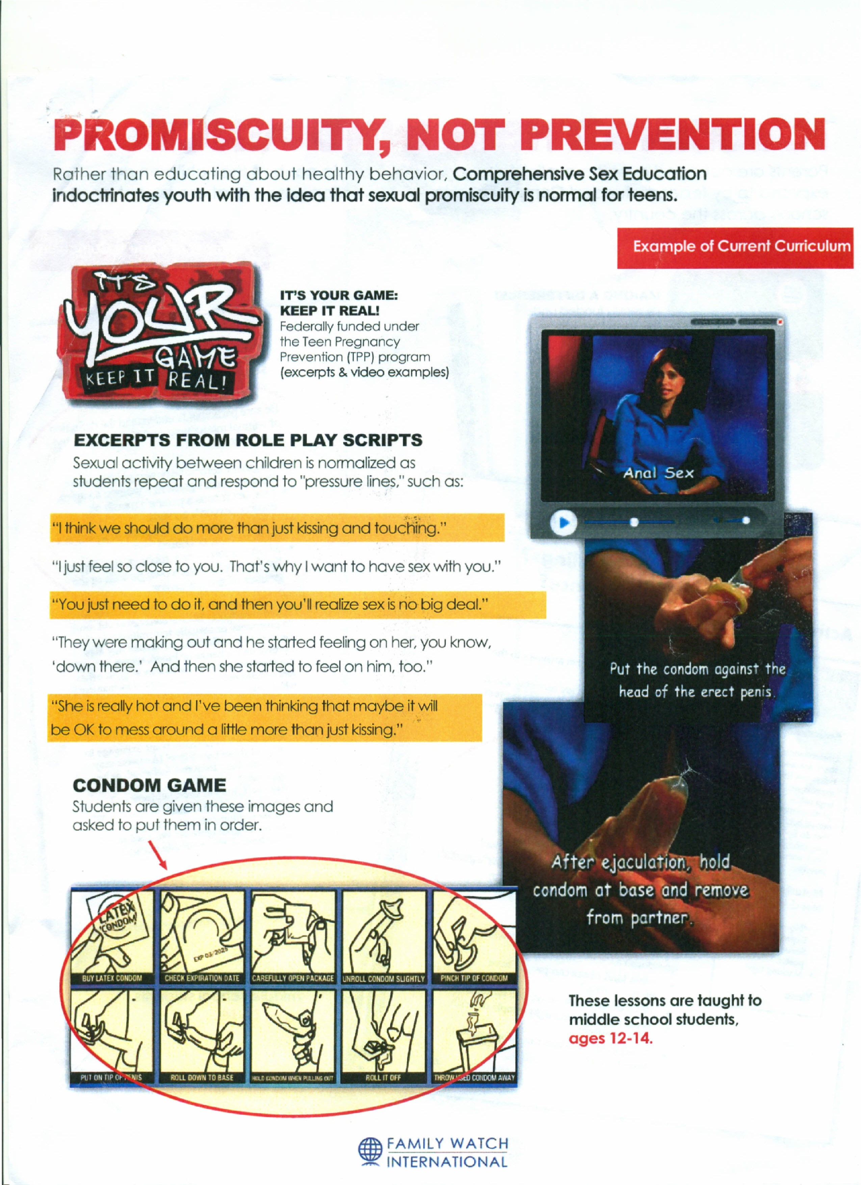
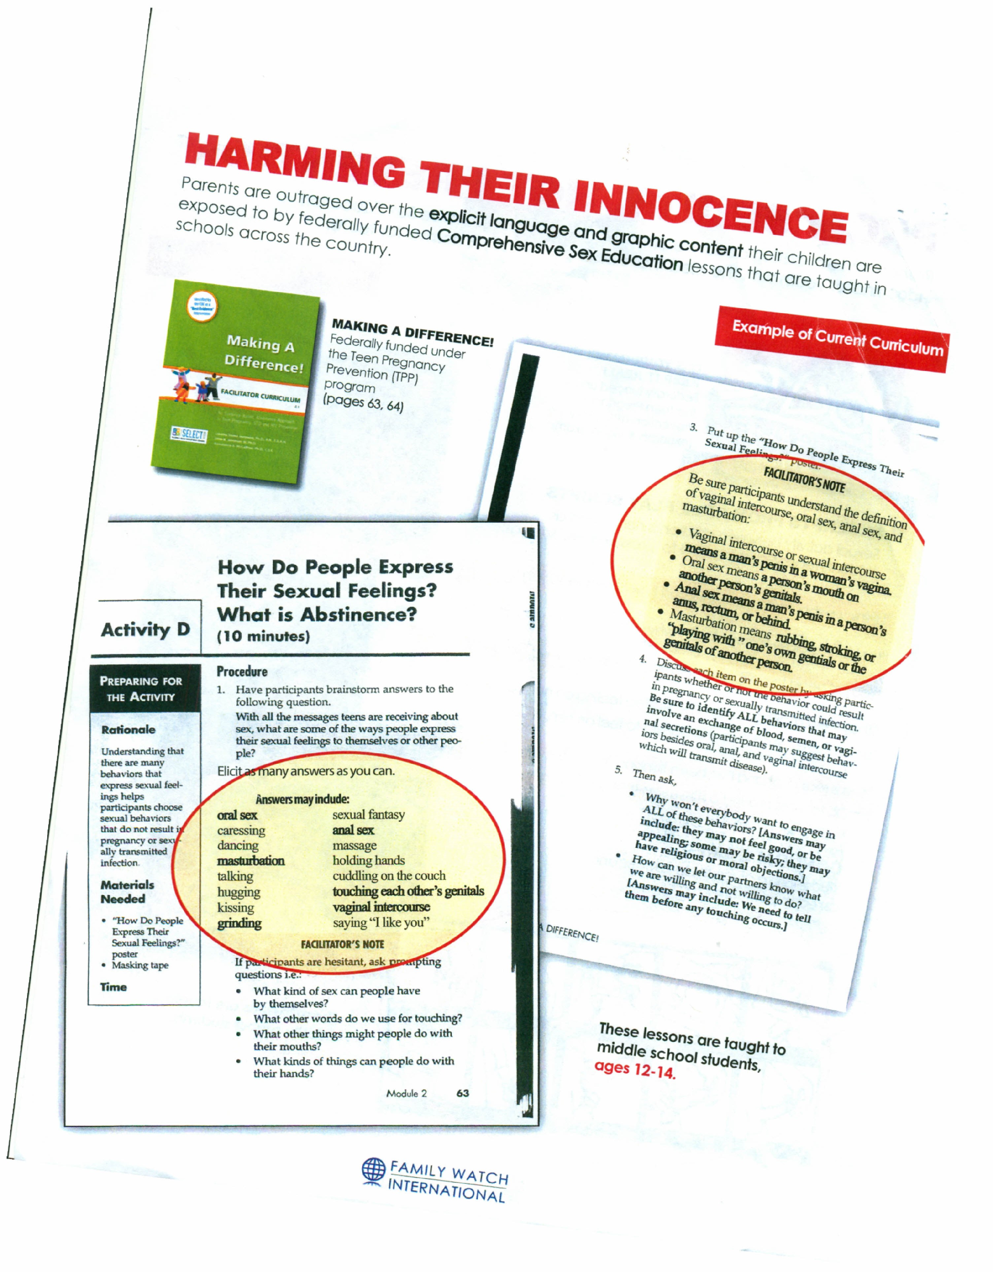

Parents Win! With Opt-In

According to the Texas Education Code, parents have the right to know what is being taught in Human Sexuality instruction and to remove their child without consequences. (See Texas Education Code.)
By law, your If school should send an Opt-In form home, what do parents do with it? What thought process goes into whether or not to include a child in the Human Sexuality instruction that has been chosen by the school district?
The current Evaluation criteria that parents use to decide whether or not to Opt-In their student seems to include: trust in school district, peer pressure, and apathy.
Trust: The trend seems to be that Parents trust the School Districts to provide appropriate instruction. A School District may host Parent Forums for the curriculum where parent attendance levels fluctuate sometimes based on the trust level in the district. Occasionally, a Parent might go to the Library to view the Curriculum in detail. But in general, Parents seem to trust that the district is providing adequate and age-appropriate instruction.
Peer Pressure: Parents feel especially compelled to opt-in their children because of Peer Pressure. Our children do not want to be singled out and parents don’t want to be the responsible party in causing any undue stress on our children. Somehow after all of these years of teaching our children to withstand peer pressure in other areas such as drugs and alcohol, we give in to the ultimate fear of being different when it comes to communal sex education.
Apathy: Apathy is the strongest power that School Districts have when it comes to our children. Parents are too busy and too distracted to take the time to really think through whether the instruction is appropriate for our unique children and their individual maturity level.
The Opt-In Process is full of inefficiencies without any guarantee or comfort for a discerning parent. The student is supposed to bring home a form in a timely manner. If a parent decides to Opt-In their child, the form has to successfully arrive back at the school and the instructor must honor the parent’s request. Without the signed Opt-In form, a student CANNOT receive human sexuality instruction.
Teachers do not always perform the due diligence to check the forms. Students are sometimes even given the option to stay in the room even though their parents did not sign the Opt-In form. There are no consequences for the teachers or students if the parent said ‘no’ in cases when the school actually delivered the lesson. The school could just say that they lost the form. Districts may not hold teachers accountable, so you must.

Students that don’t Opt-In are sometimes given more book work than the students that actually go through the class. In some cases, instruction is reduced from 10 days to 4 days, but the book work is for the full 10 days. Most of the work would be considered ‘busy work’ and sometimes includes quiz and test reviews with threats of a quiz or test at the end. Students not only feel singled out, but they feel like the Opt-In is a punishment.
Material: The School District is required to make the material available for public inspection. Many School Districts keep the documentation in the School Library for Parents to review. Some curricula are available online to review and even more have reviews available. The Parents should discern the source of the reviews and financial backing of such Material. Many curricula available are backed by Planned Parenthood and the National Sex Ed Standards. Is it alarming to parents that an Abortion Provider would be supplying the Human Sexuality material to their children? What message would this group provide a student? Is it abstinence based or comprehensive sex education? The possible questions and research criteria for Parents are another topic altogether. But Parents should seek to understand as much as possible about the source of the Material. Each District in the State of Texas is required to have a School Health Advisory Council that makes recommendations to the Board of Trustees. Parents can seek out other Parents that are on the Council to understand what Curriculum is taught and how the District determined its appropriateness.
Instructor: Parents need to know and understand who is teaching the material. Sex Education is Character Education. If the curriculum is supposed to Abstinence-Only, is the instructor able to deliver a compelling message for Abstinence?
Peer Group: Many programs have interactive discussions. Some programs are merely instruction using anonymous note cards for questions. The Instructor’s guidance through this discussion is an important part of a Parents decision. Does the Instructor read/entertain every question or is discretion built into the program and presentation? Parents should be aware of the Peer Group that is in the room for the instruction.
An Opt-In process is made efficient when the Parent signs the form and the Instructor sends a notification to the Parent acknowledging receipt and intent to honor the request. Write, ‘Please confirm receipt’ at the bottom of your child’s Opt-In form and pursue a response.
My hope is that discerning parents do not give in to blind trust, peer pressure, and apathy. We should all know without any doubt that the instruction that is being provided is exactly what our child needs at that time in his/her life.

PARENT ACTION GUIDE

- Contact your school principal and let him or her know if you do not want curricula, anti-bullying programs, and/or lessons that teach human sexuality or LGBT issues to your children. Use our Opt Out Form.)
- Ask what programs, lessons, or events, or school decorations are currently in place that cover this subject matter. Ask which have an option to opt out and which do not. If lessons are available, go review them. You can also sit in on lessons to see what is being taught,

- Do not opt-in your child into human sexuality lessons that you are not comfortable with, and teach your child what you think they need to know. Please see the Resources page for curricula that can be used at home.
- Ask what the school's policy is regarding bathrooms and changing facilities being used by students of opposite biological sex.
- Ask what the school's policy or plan is if a student's parents decide to transition him/her to the opposite sex.
- Visit your child's library and ask to see the books that cover sexuality and LGBT. Speak to the librarian about which books you do not want your child to check out or look at while in the library. Teach your child that if they open a book and encounter images that are uncomfortable or don't seem right to them, they should just close the book.
- Write to school officials, lawmakers, and newspapers.
- Attend your local SHAC meetings. Apply for membership.
- Encourage other parents to get involved and to know exactly what their children are being taught about sexuality.
- Teach your children to treat all people with kindness and respect. Model respectful behavior towards people who think differently from you, so they can know that disagreement does not equal hate.

Texas State Parent and Student Opt-Out Notice

Please take notice that pursuant to Texas Education Code §§26.010 and 38.001(1)(B) and 20 U.S.C. §1232(h) my child is to be excused and exempted for the current school year from the following school instruction and/or activities as indicated by the boxes checked below.
☐ Exemption from Instruction – Pursuant to §26.010(A) this shall serve as a written notice that, due to personal religious and moral beliefs, my child is to be temporarily removed from a class or other school activity as follows: _____________________________________________________________________________________
_____________________________________________________________________________________
_____________________________________________________________________________________
☐ Immunization – Pursuant to §38.001(1)(B) this shall serve as a written notice that I decline to give my child immunizations for reasons of conscience, including religious belief. ☐ Private Information – Pursuant to 20 U.S.C. §1232(h), absent my written consent, none of the following may be undertaken regarding my child: the administration of any survey, analysis or evaluation that reveals (1) political affiliations or beliefs of my child or me, (2) mental or psychological problems of my child or his or her family, (3) sexual behavior or attitudes, (4) illegal, anti-social, self-incriminating, or demeaning behavior, (5) critical appraisals of other individuals with whom respondents have close family relationships, (6) legally recognized privileged or analogous relationships, such as those of lawyers, physicians, and ministers, (7) religious practices, affiliations, or beliefs of my child or me, or (8) income (other than that required by law to determine eligibility for participation in a program or for receiving financial assistance under such program).

Keep this signed, written notice on file in my child’s cumulative folder.

Child’s Name ______________________________ Grade Level__________ Date____________
Parent/Guardian’s Name(s) _________________________ ______________________________
Parent/Guardian(s) Address ________________________________________________________
Parent/Guardian’s Signature(s) _________________________ ___________________________
Daytime/Evening Phone Number(s) _____________________ ___________________________
School Name ______________________________ School District ________________________
Received by (Print Name) ___________________________________________________
Received by (Signature) _______________________ Date Received _________________

Suggested Texas School Board Policy:
Uphold Texas Age of Consent and Biological Reality
The policy of our school district is that all employees, including administrators and teachers of our Texas schools, will uphold all state laws regarding the age of consent for sexual activity, which is 17.
Neither Planned Parenthood nor any organization affiliated with Planned Parenthood, or any other abortion provider or affiliate, including without limitation, (Future of Sex Education (FoSE) Initiative; Sex, Etc.; Advocates for Youth; Answer – Sex Ed Honestly; SIECUS (Sexuality Information and Education Council of the U.S.); The Kinsey Institute; GLSEN (Gay Lesbian Straight Education Network); and Gay Straight Alliance) will be allowed on our campuses or any access to our students. No personnel from these organizations will be allowed access to our students, either through digital platforms or through printed curricula, books or other media.
No information shall be provided to minors that encourages sexual experimentation and conduct outside the bonds of marriage. This includes sexually explicit material in library books, assigned reading material or digital content.
No material that meets the definition of "harmful to minors," which could be defined as obscenity, under Texas Penal Code §43.24, will be presented to our students in any form regardless of any claim that the material is being presented for educational, scientific or governmental purposes.
Contributing to the delinquency of a minor is a crime in Texas. We will ask for prosecution to the full extent of the law if any school employee encourages under age minors to engage in any illegal behavior, especially relating to illegal drugs, smoking, consuming alcohol, or sexual behavior.
The policy of our school district is that our children will only be taught objective reality, including objective biological reality. The harmful artificial construct of reality called transgenderism will not be taught or presented to our students. This includes books in our school libraries and any assigned reading material or digital material.
1. The official position of this Texas school with respect to transgenderism is that there are only two biological genders: male and female. This shall be the official position of ALL schools in the district in all policies and in teaching materials presented to the students.
2. Children will not be taught that they can be any gender they desire or feel that they are.
3. Children will be taught that sex is biological and immutable, because that is objective biological reality.
4. Gender dysphoria will be taught and described as a mental health condition to be treated with respect and dignity, as with any other physical or mental disability. Gender dysphoria is defined as "Unhappiness with one's biological sex or its usual gender role, with the desire for the body and role of the opposite sex".
5. Students with gender dysphoria will be given the option of using the facilities assigned to their biological sex or private accommodations for restrooms, showers, lockers, and changing facilities.
6. No exceptions will be made to this policy for 504 plans. Transgender theory is controversial, potentially harmful, and unproven and should not be used in 504 plans.

Suggested Texas School Board Policy:
Uphold Texas Age of Consent Law
The policy of our school district is that all employees, including administrators and teachers of our Texas schools, will uphold all state laws regarding the age of consent for sexual activity, which is 17.
Neither Planned Parenthood nor any organization affiliated with Planned Parenthood, or any other abortion provider or affiliate, including without limitation,
- Future of Sex Education (FoSE) Initiative;
- Sex, Etc.;
- Advocates for Youth;
- Answer – Sex Ed Honestly;
- SIECUS (Sexuality Information and Education Council of the U.S.);
- The Kinsey Institute;
- GLSEN (Gay Lesbian Straight Education Network);
- and Gay Straight Alliance
will be allowed on our campuses or any access to our students. No personnel from these organizations will be allowed access to our students, either through digital platforms or through printed curricula, books or other media.
No information shall be provided to minors that encourages sexual experimentation and conduct outside the bonds of marriage. This includes sexually explicit material in library books, assigned reading material or digital content.
No material that meets the definition of "harmful to minors," which could be defined as obscenity, under Texas Penal Code §43.24, will be presented to our students in any form regardless of any claim that the material is being presented for educational, scientific or governmental purposes.
Contributing to the delinquency of a minor is a crime in Texas. We will ask for prosecution to the full extent of the law if any school employee encourages under age minors to engage in any illegal behavior, especially relating to illegal drugs, smoking, consuming alcohol, or sexual behavior.

Suggested Texas School Board Policy:
Objective Biological Reality

The policy of our school district is that our children will only be taught objective reality, including objective biological reality. The harmful, scientifically unproven artificial construct of reality called transgenderism will not be taught or presented to our students. This includes books in our school libraries and any assigned reading material or digital material.
1. The official position of this Texas school with respect to transgenderism is that there are only two biological genders: male and female. This shall be the official position of ALL schools in the district in all policies and in teaching materials presented to the students.
2. Children will not be taught that they can be any gender they desire or feel that they are.
3. Children will be taught that sex is biological and immutable, because that is objective biological reality.
4. Gender dysphoria will be taught and described as a mental health condition to be treated with respect and dignity, as with any other physical or mental disability. Gender dysphoria is defined as "Unhappiness with one's biological sex or its usual gender role, with the desire for the body and role of the opposite sex".
5. Students with gender dysphoria will be given the option of using the facilities assigned to their biological sex or private accommodations for restrooms, showers, lockers, and changing facilities.
6. No exceptions will be made to this policy for 504 plans. Transgender theory is controversial, potentially harmful, and scientifically unproven and should not be used in 504 plans.

STUDENT PHYSICAL PRIVACY POLICY

I. PURPOSE
In recognition of student physical privacy rights and the need to ensure student safety and maintain school discipline, this Policy is enacted to advise school site staff and administration regarding their duties in relation to student use of restrooms, locker rooms, showers, and other school facilities where students may be in a state of undress in the presence of other students.
II. DEFINITIONS
“Sex” means an individual’s immutable biological sex as objectively determined by anatomy and genetics existing at the time of birth. An individual’s original birth certificate may be relied upon as definitive evidence of the individual’s sex.
III. POLICY
- Use of School Facilities
  - Notwithstanding any other Board Policy, every public school restroom, locker room, and shower room accessible by multiple persons at the same time shall be designated for use by male persons only or female persons only.
  - In all public schools in this District, restrooms, locker rooms, and showers that are designated for one sex shall be used only by members of that sex; and, no person shall enter a restroom, locker room, or shower that is designated for one sex unless he or she is a member of that sex.
  - In any other public school facility or setting where a person may in a state of undress in the presence of others, school personnel shall provide separate, private areas designated for use by persons based on their sex, and no person shall enter these private areas unless he or she is a member of the designated sex.
  - This section shall not apply to a person who enters a facility designated for the opposite sex:
        - for custodial or maintenance purposes, when the facility is not occupied by a member of the opposite sex;
        - to render medical assistance; or
        - during a natural disaster, emergency, or when necessary to prevent a serious threat to good order or student safety.
  - Nothing in this section shall be construed to prohibit schools from adopting policies necessary to accommodate disabled persons or young children in need of physical assistance when using restrooms, locker rooms and shower rooms.
- Accommodation for Students Desiring Greater Privacy
Students who, for any reason, desire greater privacy when using a facility described in subsection A may submit a request to the principal for access to alternative facilities. The principal shall evaluate these requests on a case-by-case basis and shall, to the extent reasonable, offer options for alternate facilities, which may include, but are not limited to: access to a single-stall restroom; access to a uni-sex restroom; or controlled use of an employee restroom, locker room, or shower. In no event shall the accommodation be access to a facility described in subsection A that is designated for use by members of the opposite sex while students of the opposite sex are present or could be present.

